**CECIL ANDREWS COLLEGE**

**ATAR Year 12 HUMAN BIOLOGY**

## **Inquiry 1 – Unit 3**

**THERMOREGULATION**

**Conditions**

Period allowed for completion of the task:

* PART I - Scenario questions (AFL) – to be completed at home (5 marks)
* PART II – Plan/Design a hypothetical investigation on thermoregulation – one class period (at school and finished at home). Completion of the introduction, materials and methods sections of the report should be done at home (16 marks)
* PART III – In – class validation test. Secondary data analysis: You will be provided with a set of results (from an investigation that somebody else has carried out) to analyse and evaluate in class, under test conditions – one class period (25 marks)

|  |  |  |
| --- | --- | --- |
|  | **Marks available** |  |
| **Part 1** | **5** |  |
| **Part 2** | **16** |  |
| **Part 3** | **25** |  |
| **TOTAL** | **46** |  |

**Task weighting**

5% of the school mark for Semester I

**Part 1**

The AFL football season now starts in February and finishes late September. When games are played on hot summer days early in the season, players coming off the field are often seen resting on the bench wearing an ice jacket or standing in front of large fans.

These infrared digital images show the effect of wearing the ice jacket.

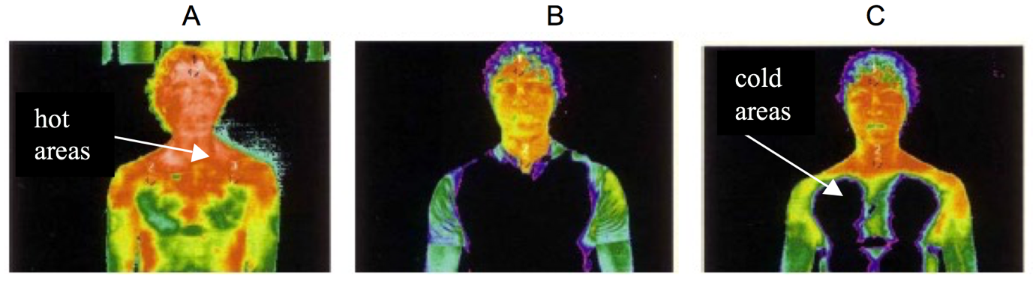(<http://www.dest.gov.au/NR/rdonlyres/45859B13-3E95-43E0-B383-7742447A1B6B/2001/STinSportReport.pdf>)

A: Player showing heat distribution immediately after coming off the ground.

B: Player when wearing the ice jacket.

C: Player immediately after removing the ice jacket.

1. What is the main method of heat lost from the skin when:
   1. wearing the ice jacket? ___________________________________ (1 mark)
   2. standing in front of the fan? _________________________________ (1 mark)
2. Players standing in front of the fan returned to normal temperature faster than those wearing the ice jackets. Explain this observation. (2 marks)

1. Is the use of ice jackets to be recommended for reducing the body temperature of athletes? Explain why or why not? (1 mark)

**PART II**

## **Investigation of temperature regulation mechanisms of the human body**

You are required to plan a hypothetical experiment based on the temperature regulation mechanisms of the human body, which will aim to investigate the responses of subjects to extremes of ambient temperature during exercise. Your introduction, materials and methods sections are required to be written up as a scientific report at home.

1. **Plan the investigation: Part 2**

Things to consider when planning your investigation:

* Research and provide background information on temperature regulation mechanisms.
* Devise a hypothesis and choose independent and dependent variables for your investigation.
* Identify variables to control.
* Identify the most accurate way to measure change in body temperature.
* Decide upon the appropriate sample size, trials and data collection methods.
* Describe in detail, the methodology you will use during your investigation.
* Decide upon the data recording method.

1. **Commence writing the scientific report (10 marks)**

* Include an introduction to the investigation.
* Include the background research on temperature regulation mechanisms.
* Write the hypothesis for the investigation.
* Identify the dependent and independent variables.

1. **Materials and method (6 marks)**

* Include a list of materials used in the investigation.
* Include details on the method used to collect the data.
* Include design featured of the investigation that ensure reliability and validity.